
Research Report: Winning Back Churned Occasional Cx in 2023 (acp-confidential-cadoc)
Jan 2023 | DRI: Kelly Peterson Working Team: Alanna Shipley Peter SergelJessica Reed Jordan CainesMeghan DesaiIshaan KansalKhalil GrellKevin FuJulia Kripke Research Brief

| Business Context & Research Questions: In current EPIC & PAD experiments we are seeing positive signals from the Nearby Low Fees restaurant offering. However initial CX research showed that Cx awareness was not as strong as it could be, they are aware they are saving money but nearby was not always top of mind.
Relevant past research: EPIC 1 Cx Reactions: Research Results (acp-confidential-cadoc) EPIC 1 Reactions Throughout the Funnel | Research Report (acp-confidential) Research Report: Padv1 Message Test (acp-confidential-cadoc)| Research Brief: Padv1 DashPass Value (acp-confidential-cadoc)
Nearby is quickly scaling which is why it is critical at this time to ensure that it is clear that we are tackling affordability in the right ways and with the right words to improve perceived affordability ratings for DoorDash. This is the time for us to take a step back and ensure that Nearby is the right anchor for this product. To do so we must ensure:

- Cx care about the offer in front of them. The solutions we provide must be clear, be liked and be a reason for Cx to come back to the DoorDash
- It makes sense to Cx. It’s clear not only when/why they are saving on fees but when/why they are not receiving those savings.
- DashPass is still desirable in the longer term and it makes sense why you would take the next step up to DashPass

For this study we will tackle items 1 & 2 of the above. Additional research will follow this initiative quickly to understand the longer term flow of Cx and additional education, resources and support needed to help eventually transition them to DashPass.

| Research Approach & Sample:
Research Approach: N=459 occasional churned occasional Cx completed a 10 min survey from 1/26- 2/6 to understand why they churn, what they need, and how they feel about our toolbox of affordability levers. The Cx included in this study were not located in markets where the Nearby test is currently live and were therefore significantly less likely to have exposure bias.

| TLDR
- Churned Cx would feel encouraged to place an order with DoorDash for “Nearby” and “Star and Save” offerings
- Additional interest in a $15 flat rate meal, particularly among those with lower incomes and/or smaller household sizes
  - There may be better PMF for lunch with this offer
- There is little difference in carousel interest if we communicate a brand vs. the value; we are not likely able to gain or lose interest over approach
- Messaging to communicate new affordability features should be evergreen in nature and speak to clear and concrete change
- Affordability work streams should ensure we are tackling affordability+. Specifically we should be focused on:
  - Quality (recently identified as a major driver of negative ratings in Q4 NPS ratings)
  - Time until delivery (particularly important at lunch)
  - Interest in home cooking/guilt for ordering
  - Portion sizes
  - Health/dietary focus

| Recommendations
- Consider experimenting with $15 flat fee during the lunch hours of 11AM - 1PM
  - Potential to expand from there
- Continue with “Nearby” as brand but continue experimentation with carousel names that include Nearby in the header vs. description
- Explore opportunities to link New Verticals, specifically grocery, with affordability options to engage Cx who prefer to cook at home
- Take a step back on affordability measures that might impact timeliness & quality to check in with Cx
  - Consider excluding these options during lunch rush hours
- Work with DashPass team to utilize DashPass loyalty program (pending) as an upsell to DashPass beyond “Nearby” or “Star and Save”

| Detailed Results

Question 1: Which affordability levers will bring Churned Cx back to DoorDash?

- Churned occasional Cx will be most motivated by “Nearby” and “Star and Save”
  - Over 80% of Cx who selected these items did so because it was easy to understand, relevant to them personally and useful to them personally
- “Everyday Affordable Meal Items ($15 flat fee)” also did well among Cx but had lower usefulness ratings indicating that it was clear and relevant but there may be less use cases where they find it valuable in the moment.
- Cx who ranked Nearby as #1 were somewhat more likely to have a larger HH size (2.91 avg ppl) than those who ranked “Star and Save” or “$15 flat rate” as their number one choice (2.61 ppl)
- Cx who ranked “$15 flat rate” as their number one choice were more likely to have an income under 50k than “Nearby” and “Star and Save” (23% v.s 18% vs. 12% respectively)
- Very few Cx (7%) indicated none of these reasons would make them want to place an order on DoorDash

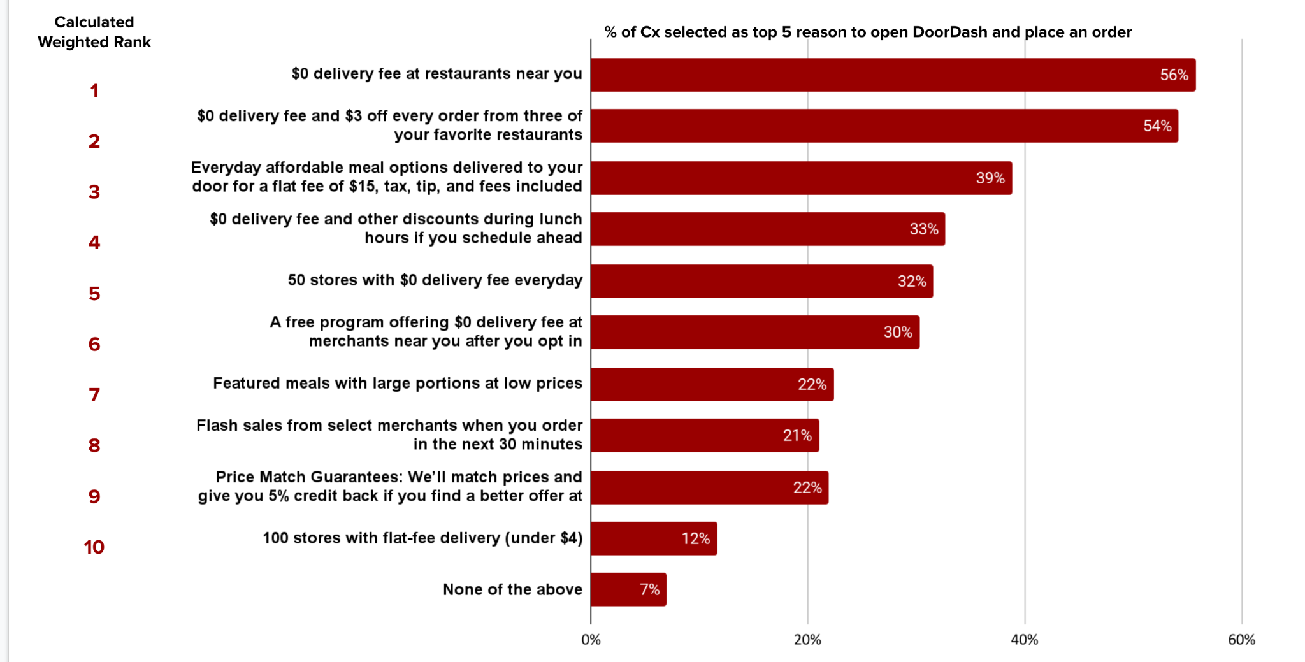

Why did Cx select their #1 answer? (in their own words)

$0 delivery fee at restaurants near you:
- “It is practical and takes away the biggest inhibiting factor that I have in ordering food.”
- “Because of the delivery fee is too much I'll just drive 2 mins to get it”
- “If there is a high delivery fee I usually will just go and pick it up.”
- “Delivery fees are a primary factor when choosing where I will order.”
- “If they’re close it makes no sense to have high fees”

$0 delivery fee at $3 off every order from three of your favorite restaurants:
- “$0 delivery fee is great on its own, but adding a $3 discount is a guaranteed order”
- “I really only order from my favorite restaurants. But with the delivery fee and top betting high, I would rather pick up the food”
- “No delivery fees mean I don’t feel guilty not picking up. $3 is icing on the cake, especially if I can choose the three stores.”
- “Because I typically only order from a few restaurants so if I could pick the three options and receive discounts, I’d be more likely to order from them. Otherwise, it’s just so expensive with the prices and fees.”

Everyday affordable meal options delivered to your door for a flat fee of $15, tax, tip, and fees included:
- “The price is eye catching and affordable”
- “It would be nice to have affordable meals at a set price with no hidden fees”
- “Often i opted not to use doordash is because the variable additional fees, so if there is flat fee known at the beginning it's helpful to estimate earlier on”
- “I can't establish a budget because there are too many pricing schemes in DoorDash. A flat fee for a full meal would encourage me to place an order.”
- “It is a easy lunch option”

Question 2: Does the “Nearby” part of Nearby really matter?

- There are no significant differences between ratings of the different carousels indicating that the presence of “Nearby” within merchandising efforts does not have a major impact.
- Removing Nearby only very slightly increases clarity while leaving Nearby slightly increases rated uniqueness.
- Previous research around Nearby indicates that the reduction in clarity is likely due to differing definitions of what “nearby” means.
- Previous research also tells us that Cx feel that Nearby logically makes sense in-terms of when you save money vs. do not save money

 | Nearby as the core brand | Nearby as the explanation for low fees | Just focusing on low fees
 | 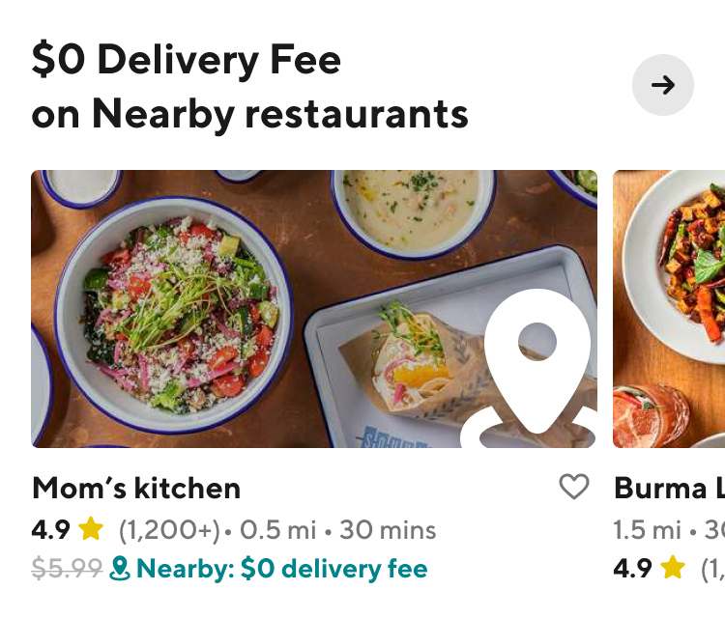 | 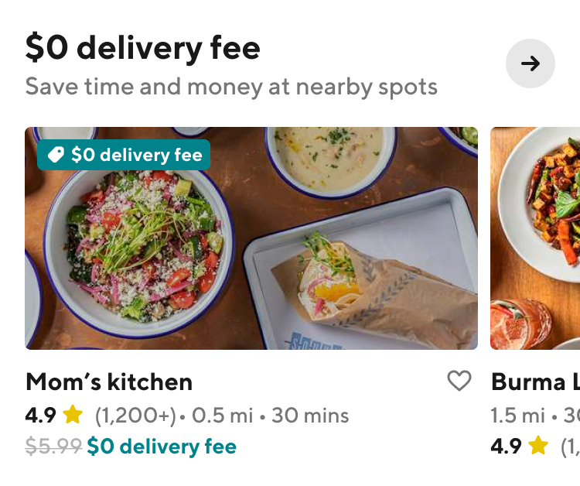 | 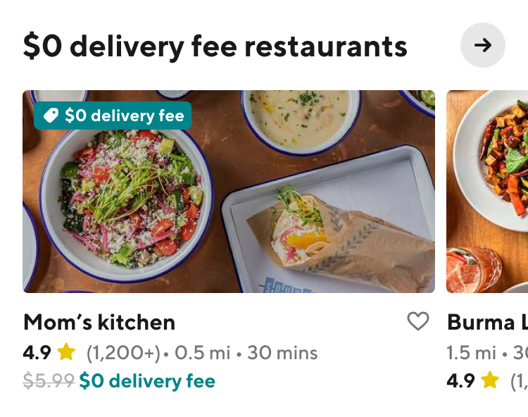
% Extremely/Somewhat Clear why saving money | 83% | 86% | 89%
% Extremely/Somewhat likely to place an order in the next week | 51% | 49% | 48%
% Strongly/Somewhat agree is valuable | 71% | 71% | 70%
% Strongly/Somewhat agree is exciting | 53% | 51% | 49%
% Strongly/somewhat agree is unique | 43% | 36% | 37%

Question 3: What messaging might be most impactful among Churned Cx?

- Cx are more interested in messaging that speaks to us specifically making a change to fees and prices.
  - It is critical that we ensure the Cx experience aligns with this messaging to maintain Cx trust.

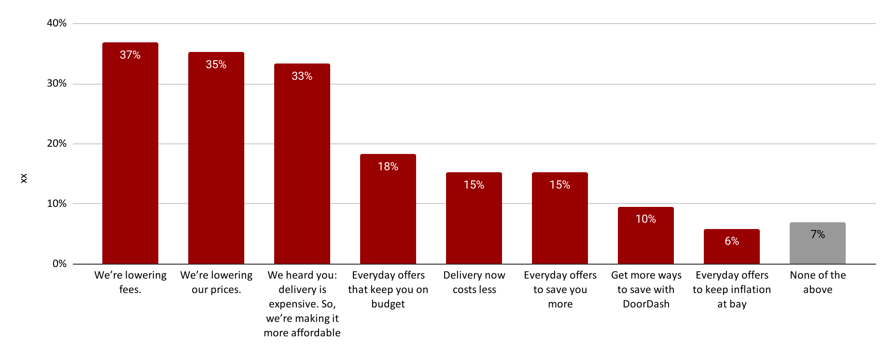

Question 4: Why are we losing Occasional Cx in the first place?

- Top stated reasons for churn include fees and item inflation, this workstream will continue to work to solve for these & Cx in these segments expressed interest in the solutions we are providing.
- Among Cx that selected “Service fees are too high”
  - Half also selected “delivery fees are too high”
  - 38% also selected “the prices for menu items are more expensive on DoorDash than going directly to the Rx”
  - 14% “feel guilty”
  - 14% “now cook at home regularly”
- Solutions will also need to tackle preference for home cooking, ordering out guilt
- Additional areas to explore include menu items that are not available on DoorDash and quality of delivery

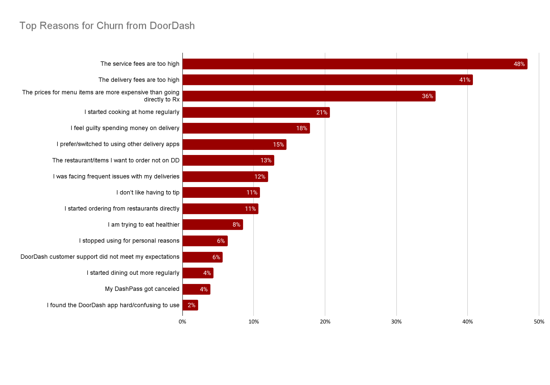

Question 5: What is most important to Churned Cx when they are deciding where to place an order?

- Affordability options continue to be paramount reasons for selecting on delivery methodology over another, however, it is critical for us to meet affordability+other concerns to ensure cost aligns with value
- Additional areas for consideration for our team:
  - 39% of Cx care about time until delivery (I don’t want to wait to save money)
  - 19% care about portion & 15% care about wide selection of cuisines (how do I get more for less)
  - 11% of Cx care about rewards/points for my order (what is in this for me, why should I come back)
  - 9% care about healthy items, 8% need their dietary needs met (I can’t sacrifice certain things to save money)

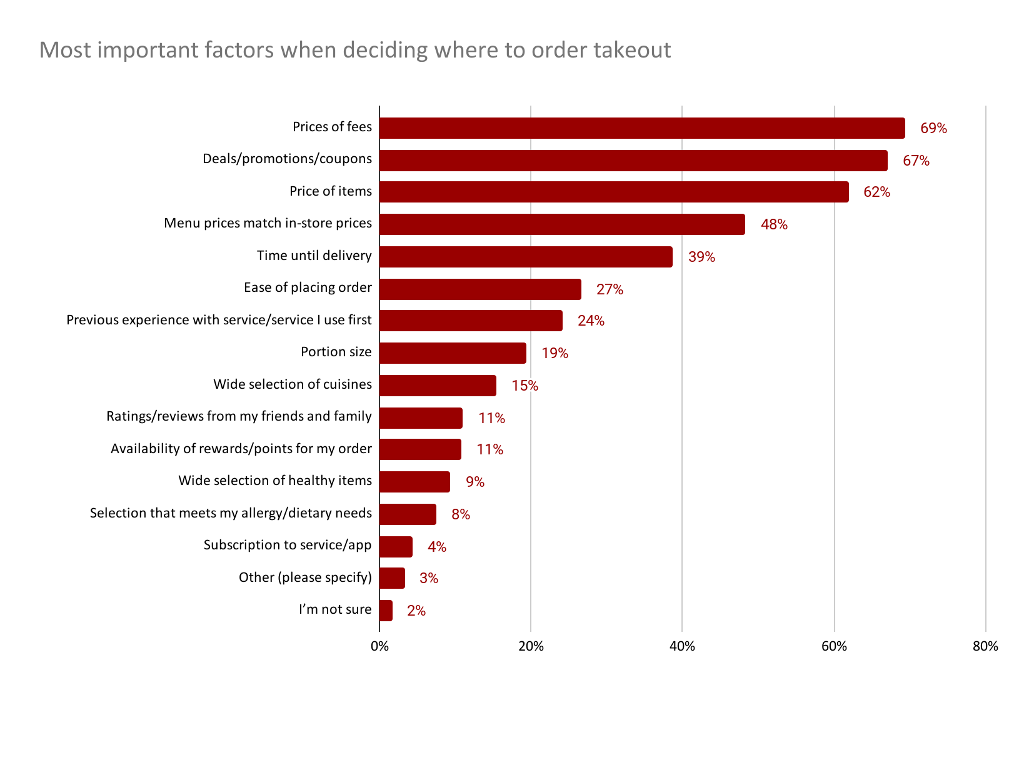

| Next steps:
- Team discussion and brainstorm on 2/8
- Additional research focusing on how DashPass fits in to the Cx journey and how Cx that have Mx Shifted feel about DoorDash affordability & DashPass

